Advanced Protection Services:

Project Plan

John Arcuri

Anthony Lynch

Brooke Kohnen

Dokyoung Kim

**Table of Contents:**

**Project Description 3**

**Project Statement 4**

**Project Mission 4**

**Project Goal 5**

**Project Objectives 5**

**Internal & External Analysis 6**

**SWOT Analysis** **7**

**Risk Analysis 8**

**Alternative Strategies** **12**

**Suggested Strategy** **14**

**Project Deliverables** **15**

**Work Breakdown Structure**  **17**

**Techniques & Concepts Used** **17**

**Control Analysis: Cost** **19**

**Control Analysis: Schedule** **19**

**Control Analysis: Quality** **19**

**Communications Plan** **20**

**BCWS** **21**

**Organizational Structure** **22**

**Organizational Chart** **22**

**Work Distribution Table**  **22**

**Project Description:**

         Advanced Protection Services (APS) is a private, armed security company with a few contracts around the Boston area with ties to the fire and police departments. They previously had a website with basic information about the company, its mission, and contact information. The website was effective for a while, but eventually was put on the back burner, was never updated, and went out of use.

         Over the past few years, the owners and partners have been operating by word of mouth for new clients, paying their employees via check, and using call or text as the main form of communication between employees. The company is hoping to bring back the old website to autonomize their current workload and modernize the company.

         The current system has worked for them in the past, but it’s time to centralize company information and give employees, clients, and the owners a versatile website that can meet the company’s needs. A big thing that the website can help with is attracting new clients. As word of mouth was used previously, the website can give the referrals a better sense of the company and potential clients can learn about the company via the website as they previously wouldn’t have been able to. The scope of the project includes but isn’t limited to:

* Defining the company’s needs in terms of a new site
* Creating a project plan that outlines individual tasks, requirements, and milestones
* Deciding what information needs to go onto the site and how the site is going to be set up
* Setting up some automation for updates or other needs
* Creating documentation for future employees using or updating the site

Outlined below is the breakdown of the project’s life cycle:

* In the initial phase of the project, the biggest piece is figuring out what the company needs in terms of the website, the preliminary ideas are:
  + A site with information so that clients are able to learn about the company and request a quote for services or a meeting
  + A possible ticketing system possibly similar to that of ServiceNow that allows work to be assigned to employees and for management to monitor the work being done
  + Payroll or HR system to hold employee information and utilize direct deposit depending on employee preference
* In the planning phase, budget will be determined. This is a crucial piece as the company doesn’t want to spend too much on a website as the last one ended up not working to their benefit. A preliminary schedule was also made with room for adjustment to compensate for any unexpected bumps along the way.
* In the design phase, the graphic designers and marketing specialists will work together to make several solid mock-ups of the website so that upper management and the sponsor can decide what will work best for their needs.
* In the development and construction phase, the team will begin to work on the development of the website. Early in, it will mostly be the programmers and cyber security specialist developing the structure of the website. Later on, the graphic designers, marketing specialist, and translator will begin working on the design aspect of the website, the branding, and translating the website into different languages.
* In the application phase, the employees will use the website by testing out the ticketing system and payroll aspect. Select clients can test out the website and give constructive feedback about anything that could be changed or improved.
* Lastly, in post completion, there will be technical support offered for updates if needed and documentation provided that can address common issues that may occur.

**Project Statement:**

The current APS website is down, so we have stopped updating the website. Previously, the website contained only company, mission, and contact information. Currently, they are rethinking their website modernization work. The project is now in its infancy, and the software-related work will take 6-12 months and involve a minimum of 10 experts. The current market competition among armed security companies is fierce, and APS will have to find alternatives to survive in the competitive market.

**Project mission:**

It is to restore the currently closed website and grow the company by managing employees and securing customers through new information and advanced security programs.

* Encourage stagnant company growth through website restoration.
* Improve the company through advanced security protocols and programs.
* We secure many customers through marketing and promotion.

**Project Goal:**

By providing more detailed data and information through the recovery of the secure website, potential customers can know the company APS.

* Restore the website and update the latest information about the company through improvements.
* We use a variety of means of contact to make it easier for potential customers to access APS. (Text messages, phone calls, online chatting, etc.

Instead of using the same program as other existing security companies, we introduce differentiated programs.

* Create a program that allows customers to remotely watch CCTV or use functions such as remote locks through ASP's website or smartphone.

We need to make a difference from existing security companies.

* Promote the welfare of armed guards.
* External factors (equipment, employee's athletic ability) are considered necessary, but internal factors such as personality, education, and service mindset are improved through training.

**Project Objectives**

* Before the official website is opened, the prototype website will be opened to collect responses and complaints from existing customers and improve the complaints. We plan to operate the prototype website until the official website is opened.
* We collect new program evaluations or complaints from existing customers to improve our website. We plan to collect complaints until the prototype homepage is completed. We also train all staff to use the new program features, and the training period will be completed before the official website launches. Educate existing customers on how to use the new program.
* We conduct employee service training for our customers. What is employee training? We plan to provide professional security education, manuals according to the situation, and regular exercise.
* Identify and evaluate the performance of your employees.
* We prepare training to fill in the gaps of our employees' gaps and evaluation materials of our employees every month. Monthly training programs or training for employees to fill gaps using standardized assessments. On a monthly and quarterly basis, we ask customers for employee evaluations and analyze them to make up for the shortcomings.
* Invest in the well-being and education of your employees. Regularly evaluate and survey staff training and customer requirements. We introduce a “Best Employee of the Month” system based on customer evaluations and award prizes or commendations to outstanding employees.

**Internal and External Analysis**

         Taking the internal and external environment into account is an important part of making sure the project result addresses all of the problems that need to be solved by the deliverable. Not only so that current problems are addressed, but also so that problems that arise in the future can be solved by the company using given processes.

The website that APS had utilized before was pretty bare boned and contained minimal information regarding the company, its objectives, and staff information. The problem wasn’t wholly with the website itself, but the fact that it wasn’t updated enough and eventually losses were cut. The goal with this new project is to create a better site that can serve more than one purpose and has dedicated support to making sure that it’s operational and updated as needed.

One of the biggest issues that APS currently has is the lack of a ticketing or work management system to keep track of which employees are working on certain tasks or projects. If enough work is coming in, it’s easy for there to be miscommunication about who’s in charge of what and the time it takes to figure it out is a waste of time and resources. The current system might work for now, but if the company grows any larger it’s going to get out of hand.

Along with the lack of a ticketing system, the company still pays its employees via paper check. This can be an effective method for some employees, but it makes recordkeeping much harder especially as the company grows. The option for direct deposit would also be easier for some employees who might not have the time to get to the bank every other Friday. The website can help to eventually integrate an online software that can help to manage the workload and payment information.

The last issue is that the current method of word-of-mouth advertising isn’t as effective as it could be with a website. The site would allow the company to be found by potential clients who might not have found them otherwise, and for the recommendations that are provided by word-of-mouth, they have a resource to learn about the company aside from the referral. With the website advertising the company would do the work itself.

Externally, the company faces a similar issue. The clients are unable to find out information about the corporation without calling someone from the company. This could be a problem for them not only in the initial phases of selecting a company to fit their needs, but if they’re giving a recommendation to someone else, it’s easier to give them a website address then to have them get in contact with someone from the company.

The lack of technology in the firm is definitely one of the biggest issues in the firm. The previous site that the company had was not only bare boned but couldn’t be found until the fourth or fifth page of a Google search. And as it’s common knowledge that most people don’t go beyond the first page of a Google search, there’s not much that the website’s promoting if there’s no visitors. By simply having their website within the first couple search results, they’re miles ahead of their competition.

Competition is another factor that APS is facing. There are a few companies in Boston who also perform similar services like Pinkerton, Allied Universal, New England and Guard Patrol Security Companies. As mentioned previously, the website will help them to reach more potential clients and clients can compare them against the competition when doing their research if they don’t have any previous knowledge of the company.

Evaluating the internal and external issues that the company is currently facing helps the project team to better understand what problems that need to be addressed and resolved throughout the process. Using this along with other analyses that were performed, the project will have better direction.

**SWOT Analysis:**

Conducting a SWOT Analysis for a private security company is an essential part of project management, especially when it comes to designing a website. A SWOT Analysis involves analyzing the strengths, weaknesses, opportunities, and threats of an individual company. It is important to have some idea about all these individual things before beginning to build a website, otherwise the entire design could become obsolete by the time it is finished. What follows is the SWOT Analysis that we have conducted for Advanced Protection Services and what we believe is important to know about the company before proceeding with the project.

*Strengths –*

* Shared employment with competitors reduces risk of being boxed out of certain jobs.
* Unique industry with limited competitors allows for strong foothold in the area.
* As an armed security company, APS has found a way to separate themselves from some of the other competitors in the region.
* With only a few corporate officers, APS limits the mistakes they could have from poor communication.
* Security is an industry that will be around for a long time, as there will always be a need for it.

*Weaknesses –*

* Being an armed security company, APS has possibly removed themselves from potential smaller scale jobs.
* Higher prices than competitors means that some employers may overlook them just to stay on budget.
* Relying on word-of-mouth advertising up to this point means that APS’ potential customers are currently limited.
* Few corporate officers allow for fewer communication issues, but it also limits the ideas that could come from a traditional corporate structure.

*Opportunities –*

* Any employer of APS has the potential of offering a security contract to them, allowing APS to have guaranteed jobs.
* Enhanced marketing strategies and the addition of a website could allow APS to expand into new areas, even potentially outside of New England.
* The addition of a website allows for far more customers to find and contact them for job opportunities.

*Threats –*

* While security is a strong industry, it can also be very volatile so job opportunities may be limited at any given time.
* There is always the threat of new competitors entering the industry or expanding their reach into APS’ target market.
* Other security companies in the area can always poach employees from APS, meaning APS needs to put ample resources towards employee retention.

**Risk Analysis:**

The Advanced Protection Service’s old website only hosted basic information about the company, its mission, and contact information. The creation and the implementation of a brand-new website for APS will incorporate these and more advanced features to autonomize and modernize their company. With the capability of processing funds via online it will reduce the cost of paper, increase the time in which employees receive these funds (for those who opt-in), and essentially be better for the environment. There have been many instances where employees received checks extremely late or not at all, in which the accountant had to be contacted. A new website would diminish these occurrences.

|  |  |  |  |  |  |
| --- | --- | --- | --- | --- | --- |
| # | RISK | IMP | PROB | CONSEQUENCES | DECISION |
| 1 | New Employee Hire | H | M | * May take a substantial amount of time to find the right hires for the job who are willing to be compensated via check only (for the time being), as independent contractors. * Risk of loss, stolen, and long waits for compensation. | * Offer an early process for checks. By negotiating how much time an employee will work prior to them working, it will speed up the process of compensation. |
| 2 | Requirements Change | H | M | * New Luddism, and dissatisfaction * Scope creep | * Allocate some additional money/time to assist in changes that may occur. Implement Change control changes in website development. |
| 3 | Human Error | M | M | * Invalid information displayed on the website itself or on behalf of an employee. * Delay employee payment. | * Ensure monitoring plans are established and followed. Additionally, implement a website feature that allows for user login so that their information regarding payment can be confirmed. |
| 4 | Budget Cuts | H | M | * Delay project completion time. * Quality may depreciate if we lose any of our resources due to budget cut. | * Ensure communication is fluid through all members that work is paid via independent contracting before hire. Ensure that an adequate amount of money is set aside to foresee and weather any incoming financial issues. |
| 5 | New Luddism | M | M | * There will be some resistance in the use of new technologies by employees who have been a part of the company for years. | * Incorporate some accommodations such as not completely getting rid of compensation via checks. Communicate the importance of the website to stakeholders as a resource for information. |
| 6 | Computer Intrusion/Website defacement | H | L | * Unauthorized access to critical information in which individuals can conduct malicious activities. * Damage company reputation. | * Ensure the hire of a well-trained, well experienced cybersecurity professional to implement proper security measures. |
| 7 | Public view Confusion (APS) | L | M | * There are a number of other companies named after “APS security”. Viewers may get confused about which is the appropriate one for this specific company. | * Ensure unique typography, and graphic images of the company's well-known employees with consent. |
| 8 | Inefficient, and ineffective Planning and reasonable time allocation. | H | L | * Potentially poor quality, higher cost, and/or delaying of project completion time. | * Effective planning involves communication with stakeholders, review of risk management, the meeting of deadlines, and reasonable cost and time allocation. Top management should be overseeing all aspects. |
| 9 | Resource Turnover (Lay off, quits, Sickness, COVID) | H | H | * Delay critical components of the website therefore delaying the project completion time. | * Encase of sickness, incorporate time off or work from home privileges or quarantining. In addition, involve some extra money and time allocation for the completion of critical components. |
| 10 | Data Loss | H | M | * Delay the process in which employees receive compensation. | * Perform backups for all website database information and ensure that it is secure. Have both digital and hard copies of information on employees. |

Scale of Importance (IMP) and Probability (PROB):

High (H) Moderate (M) Low (L)

**1.** **Choose the core team.**

ASP realized that new strategies were needed to expand and secure the company's market, and a total of 11 people formed a project team, including graphic designers, marketing experts, accountants, translators, sponsor experts, cybersecurity experts, two programmers, and two company owners. All of them have authority over information and resources both internally and externally.

**2.** **Definition of MOV.**

To achieve the organization's goals, it will collect information such as employees' requirements, means necessary for the company, and financial matters and then execute the MOV. MOV focuses on getting the maximum effect at an efficient cost.

* Within 180-365 days from November 01st, 2021.
* Within the official website opening date is set to November 1, 2022.
* It is expected to be approximately $130,000, including the website opening request cost and various costs.

**3. Identify Alternatives**

* **Strategy to open a website.**

Currently, ASP is not operating its website. Now, most businesses, as well as many other armed security companies, use their websites. In addition, it will be possible to increase the efficiency of employees' work by checking their work schedules and checking their salaries online through the website. In other words, it is expected that ASP will be able to attract more customers and further develop the company by opening a website. The cost of opening a website through a request from a website designer is about $6700. In addition, the employment cost of web security experts is about $122,500 a year.

* **Strategy to improve employee welfare.**

Currently, many armed security companies are being newly created, and they are also recruiting the people they saved during the COVID-19 situation, but it is not easy to recruit. In addition, new competitors are also scouting existing employees of other companies to cover the number of people. The ASP should prevent employee departure by improving employee welfare to prevent such employee departure. It supports employees' education expenses and medical benefits for employees' families. According to the 2018 Labor Statistics Bureau study, the average annual welfare cost per employee is about $21,700. Assuming that 100 employees are working on the assumption that each worker provides $21,000 in yearly welfare, the ASP will require a huge amount of about $2,100,000.

* **Promotion and marketing strategies.**

Currently, ASP is looking for work through word of mouth or by introducing existing customers. For ASP to grow bigger, it is to identify consumer needs through hiring marketing experts and to enable consumers to feel interested in ASP through market research and propaganda promotion. Annual marketing expert employment costs about $50,000, and advertising (Billboard Adds, Bus Adds, TV Adds) costs about $1,000,000 per month. The 30-second TV commercial to Boston is priced at $10,000 per episode. Bus ads and Billboard Adv, other than TV advertisements, also require a lot of money.

**4. Define total cost of ownership**

Employee welfare improvement options were excluded due to high initial costs. The next chance, promotion, and marketing are not higher than the first option cost, but it was excluded because the indirect price required to meet the number of people needed for marketing and promotion is high and will not work in a short time. Finally, the website opening option was the most reasonable and effective solution at the moment. This is because it can achieve lower costs and faster effects than the previous two options.

**5. Define Total benefits of ownership**

The option to improve employee welfare is to increase employees' loyalty and work hard with dedication. However, the problem is that the cost incurred for this is too high. Promotional and marketing options are to attract customers through company promotion and marketing. However, it will take a lot of time to secure customers, and I am not sure that these promotional and marketing strategies can be effectively applied. Lastly, the website is open. It is the most effective way to attract customers effectively with less cost and time than the previous two options. This is because public relations and marketing activities will be possible through continuous website management, and employees will be able to focus more effectively on their work through the website.

**6. Analyze Alternatives.**

After carefully reviewing several options, we decided that employee welfare improvement strategies and marketing and promotion strategies did not match.

Currently, new customers are needed for ASP to expand its market. Improving employee welfare, marketing, and promotion will help expand the market. However, it takes a lot of money and time to use two strategies. However, opening a website in less time and cost than the previous two options. Also, by opening a website, potential customers will become aware

of ASP. In the future, through continuous management and upgrade of the website, we can use enough publicity and marketing strategies on the website. We can get positive results through effective use of employees' schedule management and salary management through continuous website function updates.

**7. Propose & Support recommendations**

One of the three highly likely options to be executed and realized was selected from three options. The chosen option is to open a website. This option received the highest score in a limited budget and received high scores in several categories, including feasibility, so I chose this option. The scale score of other options did not exceed 3.0, but the scale score of this website opening option was 4.5. It is evaluated on a scale of 1 to 5.

|  |  |  |  |  |  |  |  |
| --- | --- | --- | --- | --- | --- | --- | --- |
| **Category** | **Weight** | **Website Opening** | | **Employee Welfare** | | **PR and Marketing** | |
| **Cost** | 0.4 | 5 | 2.0 | 1 | 0.4 | 3 | 1.2 |
| **Fulfillment of Requirements** | 0.25 | 5 | 1.25 | 2 | 0.5 | 3 | 0.75 |
| **Efficiency** | 0.2 | 4 | 0.8 | 4 | 0.8 | 2 | .04 |
| **Risk** | 0.1 | 3 | 0.3 | 2 | 0.2 | 3 | 0.3 |
| **Feasibility** | 0.05 | 4 | 0.2 | 2 | 0.1 | 2 | 0.1 |
| **Total** | 1.0 | 21 | 4.55 | 11 | 2.0 | 13 | 2.75 |

SCALE: 1 2 3 4 5

Strongly Dissatisfied Strongly Satisfied

**Project Deliverables:**

When it comes to Project Management, laying out the Project Deliverables is absolutely necessary to ensuring the project runs smoothly. Project Deliverables are the tangible checkpoints that those involved in the project can attempt to accomplish in order to stay on track. There are many project deliverables involved when it comes to designing and building a website, especially when it comes to a business as unique as armed security. The following is a list of the Project Deliverables for this particular project.

* Project Proposal, used to present to all stakeholders included in the project, to make sure everyone is on the same page and agrees on the goals and objectives of the project.
* Project Plan to lay out all of the most essential portions of the project and keep everyone on the same page through the whole process. The Project Plan includes all of the following sections:
  + The Project Description, briefly explaining what the project is.
  + The Project Statement, Mission Statement, Goals and Objectives, going into detail about what the project actually aims to accomplish after completion.
  + The Project Strategy, analyzing all aspects involved with the company the project is for and determining the best possible strategy to go about the project.
  + The Project Deliverables, describing each step that should be achieved on the way to fully completing the project.
  + The Project Planning & Scheduling, laying out the timeline for the big picture and each individual aspect of the project. This section includes the Work Breakdown Structure, describing who is responsible for which aspects of the project.
  + The Project Communications, Control and Evaluation, which is in place to make sure the quality and risks involved in the project don’t go completely off the rails by the end. This is also used to ensure that the communication between all stakeholders in the project is never compromised.
  + The Project Organization, including the organizational structure and chart and if and how it will change and the completion of the project.
* A Design Plan for the website that will be approved in advance by the stakeholders and project sponsors.
* A Budget Plan to make sure the project does not go wildly above the price it was expected to.
* A list of requirements from the project sponsors, laying out all aspects of the design that are needed to complete the project.
* A Home Page for the website that provides all needed information about APS to any potential users.
* A Booking Page that allows users to book APS for any upcoming events or jobs.
* A Contact Us Page that allows users to get in touch with someone at APS if necessary or for any questions that arise while they are on the website.
* An About Us Page that explains APS’ mission statement, their culture and who they want to be seen as by the website users.
* A Legal Page that explains any legal implications and liabilities involved in hiring an armed security company.
* A Gallery Page displaying the most professional photos of APS’ security guards on the job to provide customers with the confidence that they are hiring the best company.
* A Google Map Inlay at the bottom of all pages that shows the location of APS’ offices/headquarters.
* A Marketing Plan for APS that involves the following aspects:
  + An advertising campaign in in Boston and the surrounding area, displaying the URL for the new website, encouraging customers to view it.
  + A deal with Google to display the new website towards the top of any searches for security companies in and around New England.
  + A deal for anyone that books on the website within the first few months of the website’s launch.
* A finished, fully functioning website that includes all aspects listed above.

**Work Breakdown Structure:**

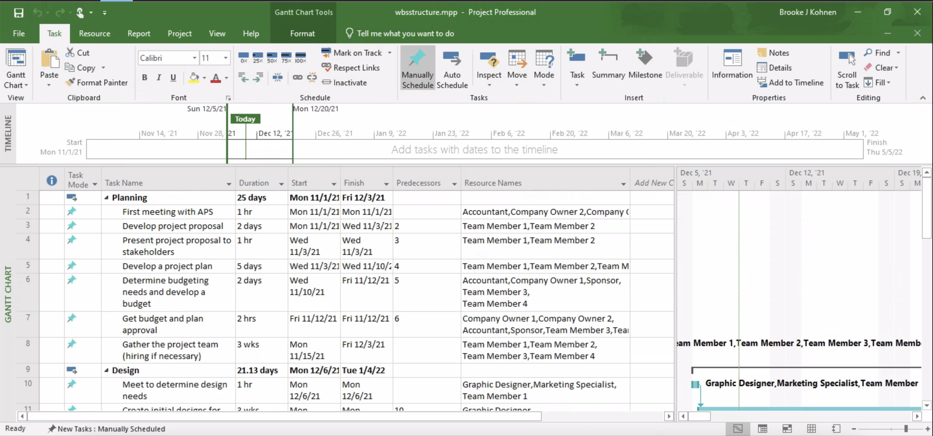

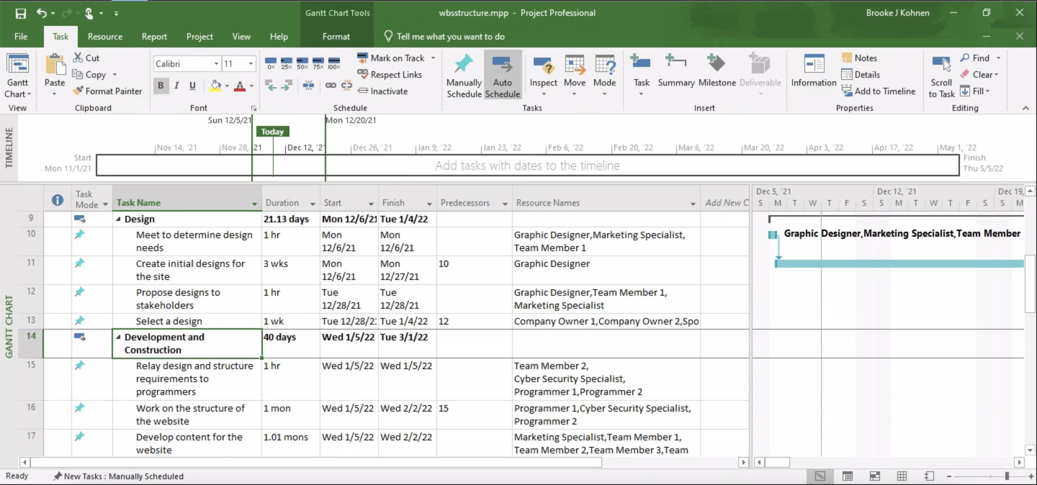

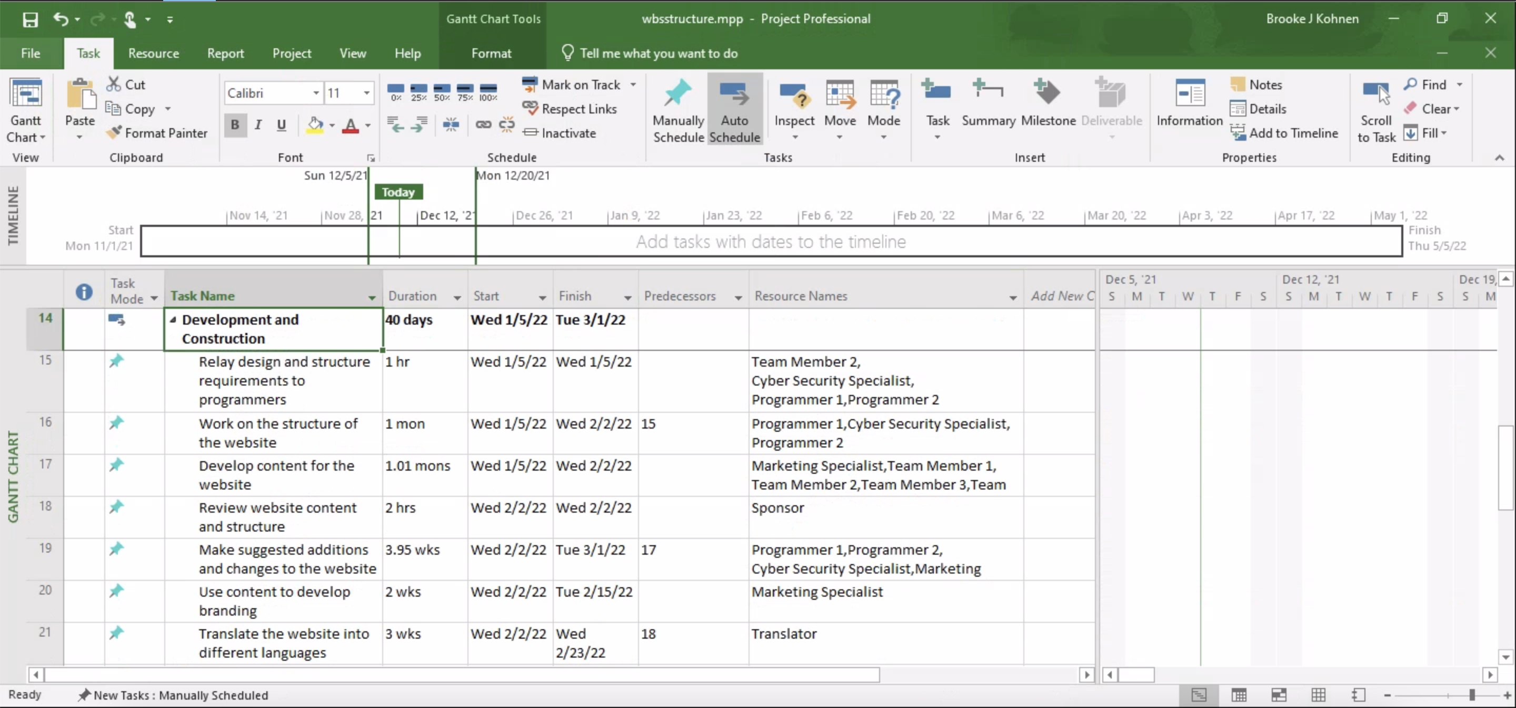

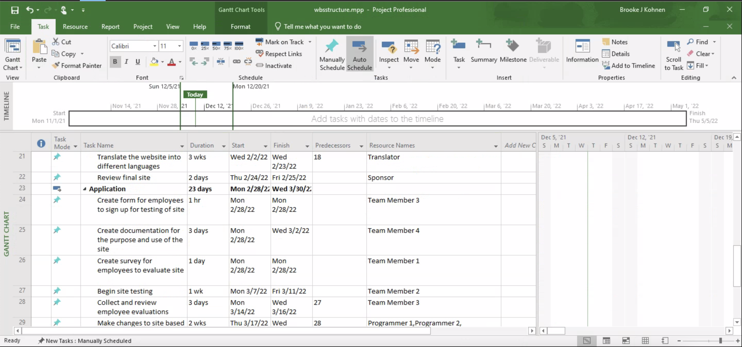

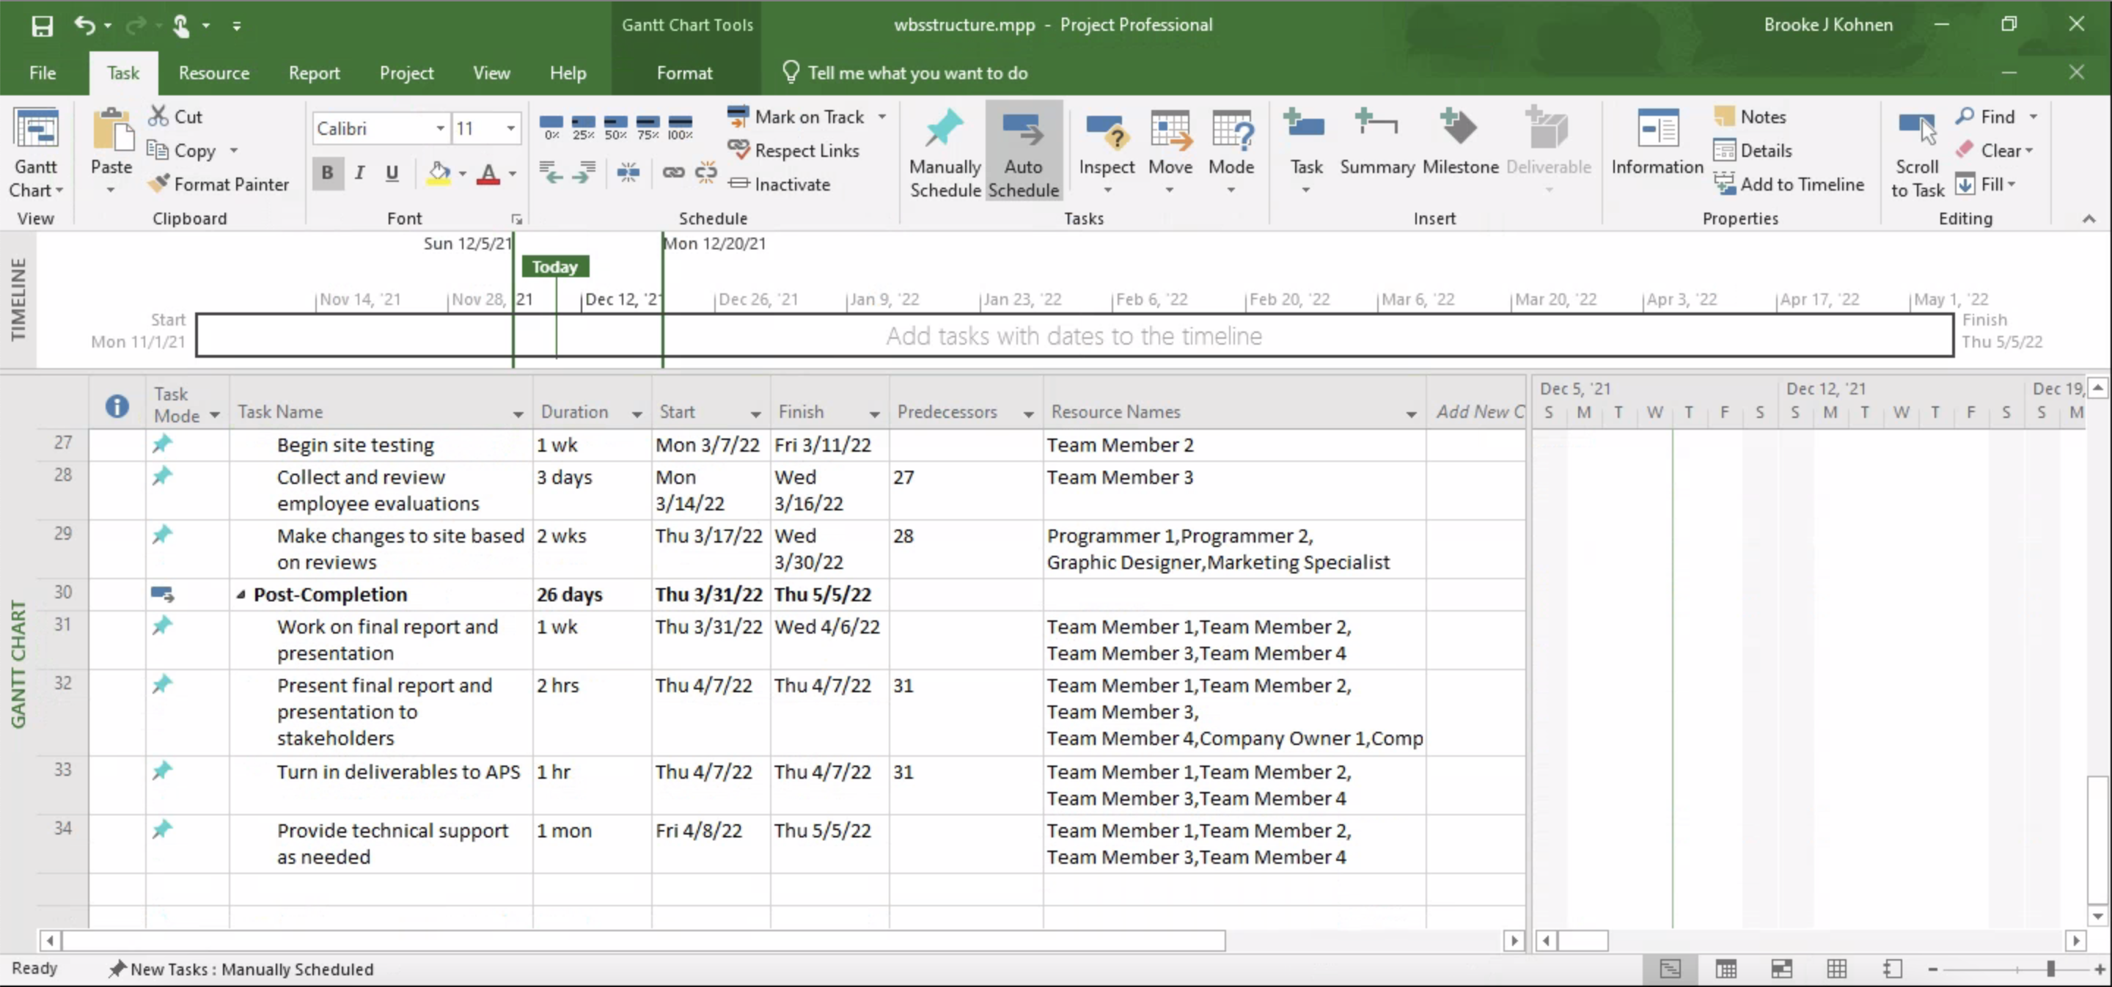

**Techniques / Concepts Used:**

As a team, an Agile approach will be utilized to perfect the software development life cycle by reviewing and improving deliverables and the process in which they were created. An agile approach is recommended because this is a smaller team with a lack of documentation, along with unique conditions, accountable developers, and clients who understand and want to get involved.

There are a series of different techniques and concepts that will be used to ensure the project’s completion. The techniques that will be used involve data gathering, data analysis, inspection, website testing, evaluations, data representation, along with a series of meetings. By gathering all the appropriate information, we, as a project management team, can ensure that all business requirements are met for the website. By analyzing this data, we can visualize and foresee what the website will look like in addition to what potential problems the company may run into. Website inspection is expected to ensure that all the website security protocols are met, as well as all the business requirements. Website testing will involve all the functional requirement aspects of the website. This will be accomplished by allowing some stakeholders to view and utilize the website to look for any bugs that need to be patched by the developers. Data representation will be used and accomplished by creating UML models to display the data transmission throughout different parts of the website including both internal and external actors, acting upon the website. Additionally, for data mining purposes a star schema will be developed with relevant information to pose solutions and better company resources. A series of meetings with other top management personnel, company leaders, and stakeholders are also essential in preparing all individuals for the task at hand, building trust, and assisting in guiding the project all the way to completion.

Mentioned in risk analysis, New Luddism also known as neo-Luddism is a philosophy that involves individuals opposing new forms of modern technologies. Because this website is a way to autonomize and modernize the company, some individuals may oppose this new development. See risk analysis chart to review the decision for this action.

**Control Analysis – Cost:**

This project team has conducted cost management through the use of assigning hourly based caps on new employees upon hire for this specific project. All employees will be paid by the hour as independent contractors since they will not be needed throughout the life cycle of the company. However, after evaluating what is associated with the creation of the website, there will have to be maintenance and security measure updates during future occurrences. With that being said, one of the cybersecurity/programmers will have to stay with the company to accommodate this requirement. Therefore, employees will be compensated only when working hourly by completing tasks regarding the project to protect against company budget cuts.

**Control Analysis – Schedule:**

This project team has conducted a schedule analysis by reviewing numerous variables pertaining to the pace that the project can be conducted at. Included in these variables are the number of full-time employees that can work on the project on a given day, the usability of different technologies that will be utilized during the project, and external data on how long similar projects took to complete. With the scope of the project already defined, and a work breakdown structure created, our project team estimates that the total project schedule will take around 6 months to complete. From the design phase all the way to the final implementation, the project will be comprehensive, requiring such a hefty schedule to achieve a polished product.

**Control Analysis - Quality**

This project team has conducted quality analysis by assessing cost management, risk analysis, the completion of a project schedule, and a communication plan. Cost management is essential because it allows the company to limit the use of its budget through compensating individuals via independent contracting throughout the project development. Risk analysis will play a part in quality analysis through assessing potential detrimental risk in the development thereby ensuring the completion of project objectives with minimal problems. The completion of the project schedule along with proper communication are key items in quality analysis by creating fluidity in deadlines as well as ensuring that each task is understood and completed in a timely manner. Website testing will also be a key factor in assessing quality analysis by ensuring that patches are applied when needed.

**Communication Plan**

As a team, especially following an Agile approach, communication is the key to success in project execution. Establishing and maintaining good communication is critical in ensuring that all members of the project including owners, top management, resources and stakeholders are coordinated and informed about the latest project information. To do this Top management will delegate meetings once a week with specific individuals at specific times to ensure that all appropriate information is addressed and accessible, prior to the project start date and while deliverables are being developed.

The purpose of this Communication plan is to define the communication requirements for the project and how information will be distributed.

|  |  |  |  |  |
| --- | --- | --- | --- | --- |
| **Host** | **Audience** | **Communication Type** | **Objective of Communication** | **Frequency** |
| Project Managers | Graphic designer | MS Teams/ Online | Agenda, Deliverables, & updates | Once a Week |
| Project Managers | Marketing expert | MS Teams/ Online | Agenda, Deliverables, & updates | Once a Week |
| Project Managers | Accountants | MS Teams/ Online | Agenda, Deliverables, & updates | Once a Week |
| Project Managers | Translator | MS Teams/ Online | Agenda, Deliverables, & updates | As Needed |
| Project Managers | Sponsor expert | MS Teams/ Online | Agenda, Deliverables, & updates | Once a Week |
| Project Managers | Cybersecurity expert | MS Teams/ Online | Agenda, Deliverables, & updates | Once a Week |
| Project Managers | Programmers | MS Teams/ Online | Agenda, Deliverables, & updates | Once a Week |
| Project Managers | Company Owners | MS Teams/ Online | Agenda, Deliverables, & updates | Once a Week |
| IT Experts | Cybersecurity expert & Programmers & Graphic Designer | MS Teams/ Online | Agenda, Deliverables, & updates | Once a month minimum/As Needed |
| Marketing Expert | Graphic designer  & Translator | MS Teams/ Online | Agenda, Deliverables, & updates | As Needed |
| Project Managers | Stakeholders/ Clients & Programmers | In person/ Office | Testing | As Needed |
| Project Managers | Full Project Team | MS Teams/ Online | Agenda, Deliverables, & updates | Bi-Weekly |
| Project Managers | Full Project Team | In person/ War room | Go-Live | End of Project life cycle |

**BCWS:**

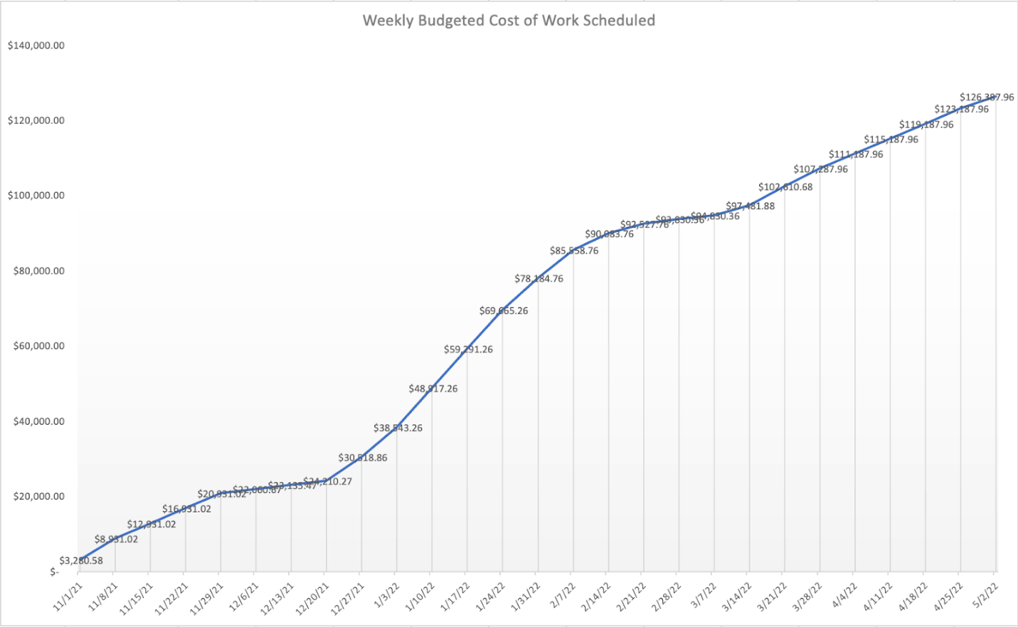

**Organizational Chart and Structure:**

APS is a small armed guard company operating in Boston. Due to the nature of this company, there is no separate IT-related project team. However, to gain an edge in the competitive market and not fall behind in the competitive market, we requested a request to open an IT department outside and created a project team consisting of employees from various departments such as management, finance, and security.

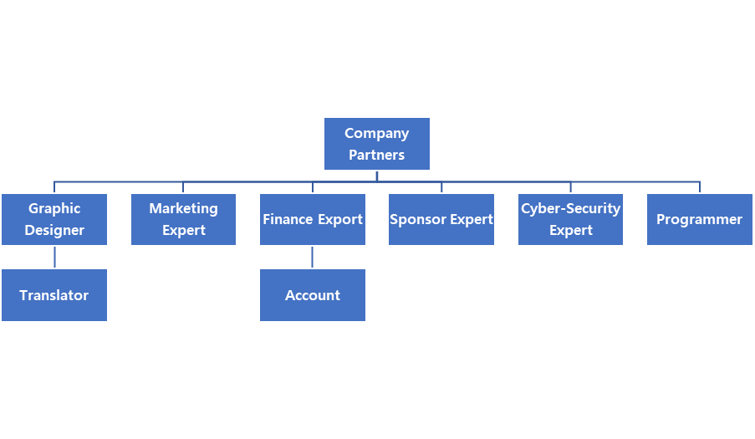

**Work Distribution Table:**

|  |  |  |  |  |  |  |
| --- | --- | --- | --- | --- | --- | --- |
| **Section:** | **Sub-Section:** | **Person Responsible:** | **Internal Deadline 1:** | **Internal Deadline 2:** | **Internal Deadline 3:** | **External Deadline:** |
| **1. Cover Page** | Cover Page | Phil | 10/4/2021 | 10/22/2021 | 10/31/2020 | 11/1/2021 |
| **2. Project Description** | Project Description | Brooke | 10/4/2021 | 10/22/2021 | 10/31/2021 | 11/1/2021 |
| **3. Project Statement** | Project Statement | Dokyoung | 10/4/2021 | 10/25/2021 | 10/31/2021 | 11/1/2021 |
| **4. Mission Statement, Goals & Objectives** | Mission Statement | Dokyoung | 10/11/2021 | 10/25/2021 | 10/31/2021 | 11/1/2021 |
| Goals & Objectives | Dokyoung | 10/11/2021 | 10/25/2021 | 10/31/2021 | 11/1/2021 |
| **5. Project Strategy** | Internal Analysis | Brooke | 10/25/2021 | 10/28/2021 | 10/31/2021 | 11/1/2021 |
| External Analysis | Brooke | 10/25/2021 | 10/28/2021 | 10/31/2021 | 11/1/2021 |
| SWOT Analysis | Phil | 10/25/2021 | 10/28/2021 | 10/31/2021 | 11/1/2021 |
| Risk Analysis | Anthony | 10/25/2021 | 10/28/2021 | 10/31/2021 | 11/1/2021 |
| Alternative Strategies | Dokyoung | 10/25/2021 | 10/28/2021 | 10/31/2021 | 11/1/2021 |
| Suggested Strategy | Dokyoung | 10/25/2021 | 10/28/2021 | 10/31/2021 | 11/1/2021 |
| **6. Project Deliverables** | Project Deliverables | Phil | 10/25/2021 | 10/28/2021 | 10/31/2021 | 11/1/2021 |
| **7. Planning & Scheduling** | Work Breakdown Structure | Brooke | 10/25/2021 | 10/28/2021 | 10/31/2021 | 11/1/2021 |
| Techniques / Concepts Used | Anthony | 11/14/2021 | 12/1/2021 | 12/12/2021 | 12/13/2021 |
| **8. Communications, Control & Evaluation** | Control Analysis - Cost | Anthony | 11/14/2021 | 12/1/2021 | 12/12/2021 | 12/13/2021 |
| Control Analysis - Schedule | Phil | 11/14/2021 | 12/1/2021 | 12/12/2021 | 12/13/2021 |
| Control Analysis - Quality | Anthony | 11/14/2021 | 12/1/2021 | 12/12/2021 | 12/13/2021 |
| Control Analysis - Risk | Anthony | 11/14/2021 | 12/1/2021 | 12/12/2021 | 12/13/2021 |
| Communications Plan | Anthony | 11/14/2021 | 12/1/2021 | 12/12/2021 | 12/13/2021 |
| BCWS | Brooke | 11/14/2021 | 12/1/2021 | 12/12/2021 | 12/13/2021 |
| **9. Organization** | Organizational Structure | Phil | 11/14/2021 | 12/1/2021 | 12/12/2021 | 12/13/2021 |
| Organizational Chart | Dokyoung | 11/14/2021 | 12/1/2021 | 12/12/2021 | 12/13/2021 |
| **10. Work Distribution Table** | Work Distribution Table | Phil | N/A | N/A | N/A | 11/1/2021 |